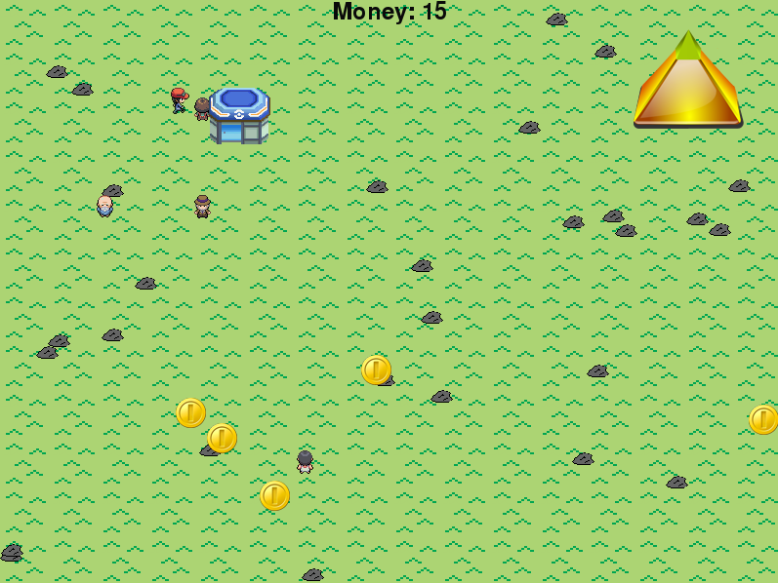Alvin Zheng

Period 3

Project Title: “Pokémon Coin Collector”

Coin Collector is a game where you play as a Pokémon trainer trying to collect coins in the world that randomly pop up. You can interact with the people in the world to buy stuff or talk. You can also change many settings like the scenery or your skin.

Objects:

Player - Can move in four directions and interact with people.

Old Man - Uses dialogue boxes to show wise quotes.

Clerk - Interact to open up the shop for the player to buy things.

Collector - Buys random things available in the shop from you for a (usually)higher price.

Runner - Runs in a square and has quotes as well.

Items - Placed by the player, they can be picked back up.

Pyramid - Interact to bring up the interface to increase potential coin income.

How to Play:

The point of the game is to collect coins and buy upgrades/decorations and explore the different possibilities for customization.

Controls:

Arrow keys - Move in the basic directions.

S – Select your skin.

G - Select the background scene.

Spacebar – Interact with an object/person.

P – Open your inventory and place something on the ground from it.

O – Change the game speed.

There is a hidden command that gives you great bonuses.